Top of Form

Question 1: Skipped

You have recently been asked to manage a project that includes people from inside and outside your organization. You need to share files with everyone on the project.

**Which Microsoft product is most suitable?**

* ​

Email

* ​

Sharepoint Online

**(Correct)**

* ​

Onedrive

**Explanation**

You can password protect files & share files with people inside and outside your organization.

Sharepoint allows sharing ***across both internal and external***

Email allows communication with all but ***not sharing***

While Onedrive also allows sharing across both internal and external. It is a less preferred option for a collaborative project document storage option. It is seen more as a personal storage option

"**Personal storage vs. collaborative storage:**

Storage use is where most of the confusion between the SharePoint and OneDrive comes into play. Yes, both options are great for cloud-based storage, **but the main differentiation is what you’re going to be putting IN said storage. OneDrive is your own personal storage. This is where you'll want to put documents and files that you don’t want other people in your organization to access.**For instance, perhaps you’re working on a document that you are not quite ready to share with your co-workers. In this case, you would want to store it in your OneDrive. While it's private, you do still have the ability to share the document with select people if and when you wish, but your organization as a whole will not have access to it without your express permission.



SharePoint, on the other hand, is your collaborative cloud storage. This is where you would store a document in which you want to collaborate with a group of co-workers. For example, lets say you’re working on a project that requires the contribution of several people. If you store this in SharePoint, anyone within your group will have access to view and even edit the document if you set the permissions to allow them to do so. **SharePoint is also where everything within Teams is stored. This is because Teams in it’s essence, is a collaboration tool.**"

**Reference:**

*https://blog.bemopro.com/cybersecurity-blog/sharepoint-vs.-onedrive*

Bottom of Form

Top of Form

Question 2: Skipped

You are managing a project with people working in different locations. To improve collaboration and team work, you are encouraging more frequent and informal communication. Which Microsoft product is most suitable?

* ​

Word

* ​

Teams

**(Correct)**

* ​

Onedrive

* ​

Yammer

**Explanation**

**Teams allows people** to chat one to one or in groups, or have audio or video calls.

Word is used for writing documents/notes and onedrive is a file sharing mechanism

Yammer is a close option but Yammer is used to communicate *within a larger group of people within an organization who are not in the same team/do not work together.*

Bottom of Form

Top of Form

Question 3: Skipped

Your organization is launching an important new product. You want to host a major online event to announce it to your industry. You will have several people speaking plus videos.

**Which combination of Microsoft products** should you use to host the event?

* ​

PowerPoint, SharePoint Online, and Stream.

* ​

Yammer, Teams, and Stream

**(Correct)**

* ​

Teams, SharePoint Online, and Stream

**Explanation**

Yammer, Teams, and Stream will allow you to use different types of content and host a major online event.

Bottom of Form

Top of Form

Question 4: Skipped

If you require frequent feature updates at a predictable channel, which update channel is best?

* ​

Current Channel

* ​

Monthly Enterprise Channel

**(Correct)**

* ​

Semi-Annual Channel (Preview)

**Explanation**

Monthly Enterprise Channel receives feature updates once a month, on the second Tuesday of the month.

Reference:

**https://docs.microsoft.com/en-us/learn/modules/get-more-done-with-office-across-devices/4-updates-service**

Bottom of Form

Top of Form

Question 5: Skipped

Which of the following terms describes the way in which OneDrive data is stored globally?

* ​

Multi-Geo

**(Correct)**

* ​

Geo-Centric Datacenter

* ​

Colocation

**Explanation**

**OneDrive Multi-Geo storage locations.** Multi-Geo is an Office 365 feature that allows organizations to span their storage over multiple Office 365 geo locations and specify in which of those to store users' data. You designate storage geographies on a per-user basis. For multinational customers with data residency requirements, you can use this feature to ensure that each user's data is stored in the geo location necessary for compliance.

Reference:

**https://docs.microsoft.com/en-us/learn/modules/get-more-done-with-office-across-devices/4-updates-service**

Bottom of Form

Top of Form

Question 6: Skipped

Which of the following Microsoft 365 subscription option is appropriate for companies with under 300 employees?

* ​

Microsoft 365 Enterprise

* ​

Microsoft 365 for business

**(Correct)**

* ​

Microsoft 365 Education

**Explanation**

***Microsoft 365 Business is designed for companies with under 300 employees.***

You can see the various subscription options and target audience elaborated in the link below

Reference:

**https://docs.microsoft.com/en-us/learn/modules/what-is-m365/3-m365-subscriptions**

Bottom of Form

Top of Form

Question 7: Skipped

Microsoft offers free trials for many of different services, and you can sign-up for a free 30-day Microsoft 365 Business Premium subscription. What is the maximum number of users included in this free trial?

* ​

10

* ​

25

**(Correct)**

* ​

50

**Explanation**

25 users is the maximum limit

Reference:

**https://docs.microsoft.com/en-us/learn/modules/what-is-m365/3a-explore-m365-tenant**

Bottom of Form

Top of Form

Question 8: Skipped

What is Windows-as-a-Service?

* ​

The ability to run Windows as a virtual desktop

* ​

Windows 10 with regular feature updates

**(Correct)**

* ​

Windows 10 Mobile

**Explanation**

Windows-as-a-Service is a new model for Windows. It provides more frequent updates, for example semi-annually, instead of installing a major new release every few years.

"**Windows-as-a-Service (WaaS) is a new way to work with the Windows desktop.**In the past, new features were released every few years, and required a significant effort to deploy. **With Windows-as-a-Service, new features are released twice a year.**By releasing new features in bite sized chunks, rather than major new versions, the work required by IT people is reduced."

Reference:

**https://docs.microsoft.com/en-us/learn/modules/get-done-stay-secure-with-windows-10/2-windows-service**

Bottom of Form

Top of Form

Question 9: Skipped

How do you control the frequency of updates with Windows-as-a-Service?

* ​

Windows updates

* ​

Deployment rings

* ​

Service Channel

**(Correct)**

**Explanation**

The service channel determines the frequency with which Windows 10 is updated with new features.

Windows updates are used to distribute fixes and security updates, and are normally distributed once a month.

Deployment rings are used to determine who gets updates, and not the frequency.

Reference:

**https://docs.microsoft.com/en-us/learn/modules/get-done-stay-secure-with-windows-10/2-windows-service**

"**Servicing channels**

Servicing channels are a method of controlling the frequency at which organizations deploy Windows 10 features. Servicing channels allow you to control how and when updates are applies. Windows-as-a-Service offers three servicing channels, each receiving feature updates at different frequencies:"

Bottom of Form

Top of Form

Question 10: Skipped

Where can reports about SharePoint activity and usage be found?

* ​

SharePoint Admin Center

**(Correct)**

* ​

Configuration Manager

* ​

Intune Admin Center

**Explanation**

**SharePoint**. Get a high-level view of the value you are getting from SharePoint in terms of the total number of files that users store in SharePoint sites, how many files are actively being used, and the storage consumed across all these sites. Then, you can drill into the SharePoint site usage report to understand the trends and per site level details for all sites.

Reference:

**https://docs.microsoft.com/en-us/learn/modules/harness-business-intelligence-with-microsoft-365-analytics-reporting/4-service-specific-admin-centers**

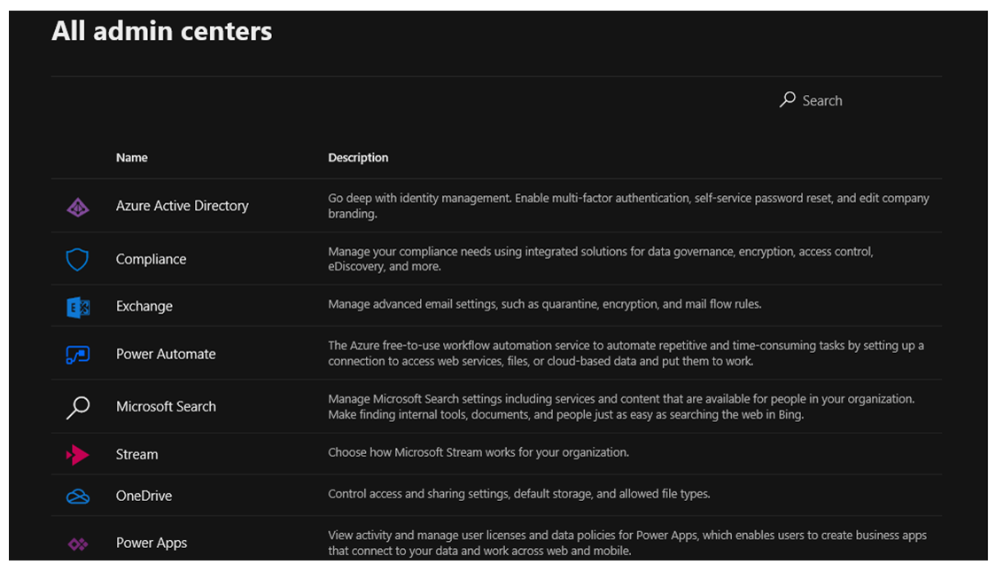

Bottom of Form

Top of Form

Question 11: Skipped

T/F: Microsoft 365 provides two subscription types for home users. Microsoft 365 Personal is for one person with single device access

* ​

True

* ​

False

**(Correct)**

**Explanation**

***Microsoft 365 Personal is for one person but with multiple devices access***

Reference:

**https://docs.microsoft.com/en-us/learn/modules/identify-licensing-options-available-microsoft-365/2-compare-home-enterprise-business**

Bottom of Form

Top of Form

Question 12: Skipped

Which of the ***following features can be found*** in the Microsoft 365 Business Premium subscription but not in the Business standard subscription

* ​

Microsoft 365 Apps

* ​

Intune

**(Correct)**

* ​

Azure Information protection

**(Correct)**

* ​

Teams

**Explanation**

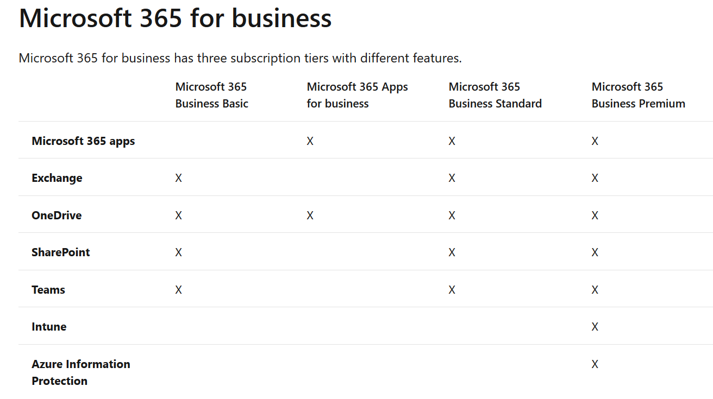

Reference:

**https://docs.microsoft.com/en-us/learn/modules/identify-licensing-options-available-microsoft-365/2-compare-home-enterprise-business**

Bottom of Form

Top of Form

Question 13: Skipped

How does Microsoft 365 reduce the total cost of risk?

* ​

By improving security

**(Correct)**

* ​

By reducing office space costs

* ​

By transforming and streamlining business processes

**Explanation**

Microsoft 365 reduce the total cost of risk by improving security.

Reference:

**https://docs.microsoft.com/en-us/learn/modules/identify-licensing-options-available-microsoft-365/6-optimize-costs**

Bottom of Form

Top of Form

Question 14: Skipped

If your Microsoft teams experiences a uptime of <95%, how much service credit are you entitled to receive?

* ​

10%

* ​

25%

* ​

50%

* ​

100%

**(Correct)**

**Explanation**

***You will get 100% credit for any uptime of <95% as per SLA***

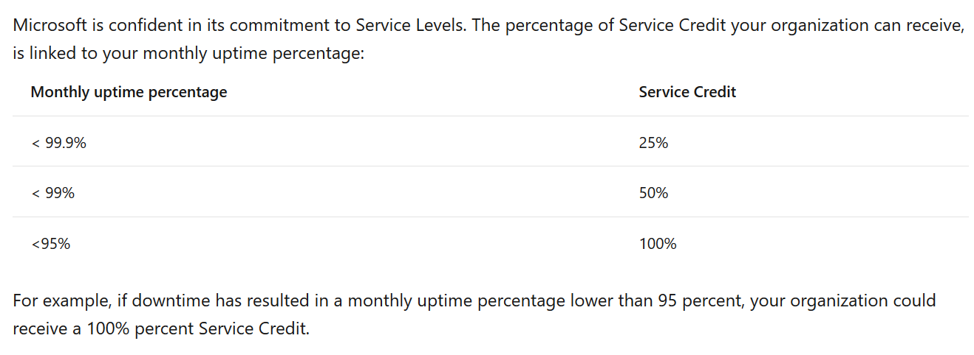

Bottom of Form

Top of Form

Question 15: Skipped

A product, or services, lifecycle typically has three phases. Which among the following is not one of them?

* ​

Specific Availability

**(Correct)**

* ​

General availability

* ​

Private preview

* ​

Public preview

**Explanation**

A product, or services, lifecycle typically has three phases:

Private preview

Public preview

General Availability (GA)

Reference:

**https://docs.microsoft.com/en-us/learn/modules/describe-service-life-cycle-microsoft-365/2-private-public-general-availability**

Bottom of Form

Top of Form

Question 16: Skipped

Which of the following statements about migration vs coexistence is true?

* ​

Coexistence is for cloud-only deployments and migration is for hybrid deployments.

* ​

Migration is for cloud-only deployments and coexistence is for hybrid deployments.

**(Correct)**

* ​

Migration and coexistence both work for cloud-only deployments.

**Explanation**

Migration is for cloud-only deployments and coexistence is for hybrid deployments.

Reference:

**https://docs.microsoft.com/en-us/learn/modules/select-a-cloud-deployment-model/4-migration-m365**

Bottom of Form

Top of Form

Question 17: Skipped

What is the underlying theory behind the Zero Trust security model?

* ​

Trust verified sources

* ​

Never trust, always verify

**(Correct)**

* ​

Verify always, trust once

**Explanation**

***The underlying theory behind Zero Trust is "never trust, always verify".***In a Zero Trust model, every access request is strongly authenticated, authorized within policy constraints and inspected for anomalies before granting access.

Reference:

**https://docs.microsoft.com/en-us/learn/modules/describe-identity-access-management-capabilities-of-microsoft-365/2-learn-identity-access-management-microsoft-zero-trust-model**

Bottom of Form

Top of Form

Question 18: Skipped

What categories are included in the Secure Score breakdown?

* ​

Identity, data, device, apps, and infrastructure

**(Correct)**

* ​

Malware and phishing

* ​

Data privacy and threat protection

**Explanation**

Secure Score includes scores for identity, data, device, apps, and infrastructure.

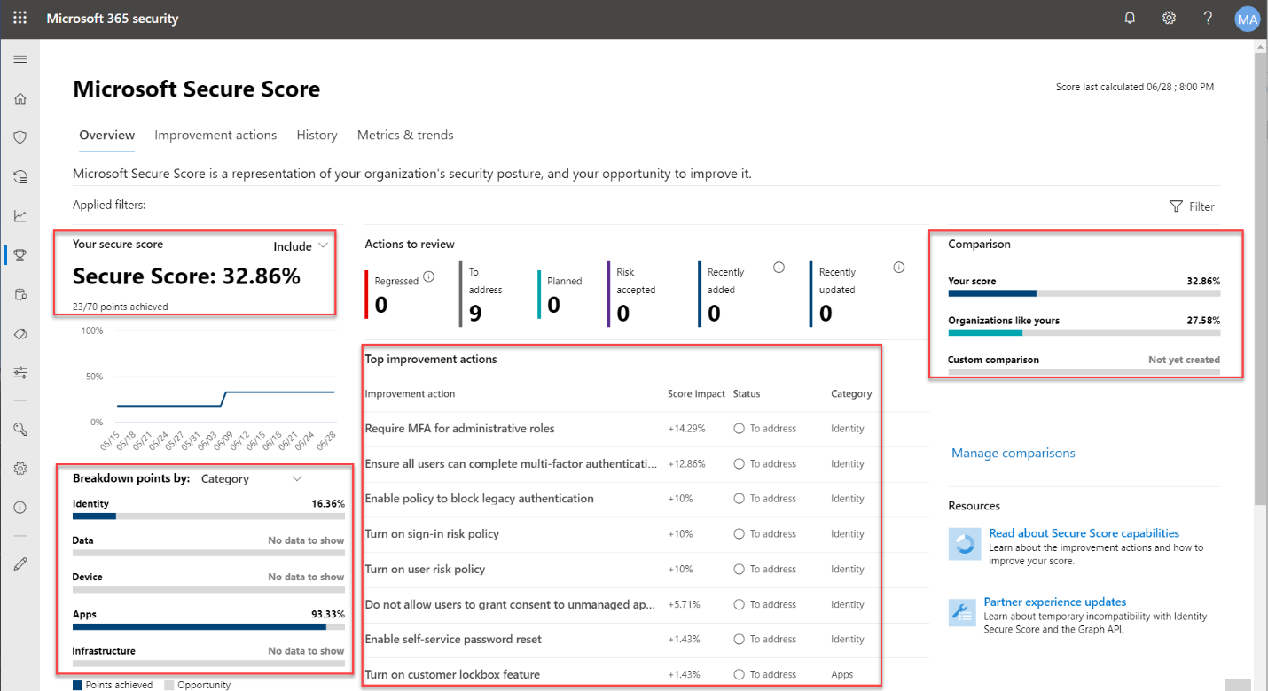

Reference:

**https://docs.microsoft.com/en-us/learn/modules/describe-threat-protection-capabilities-of-microsoft-365/4-understand-security-posture**

Bottom of Form

Top of Form

Question 19: Skipped

Which service integrates with MCAS to discover cloud app usage beyond the corporate network?

* ​

Microsoft Defender for Endpoint

**(Correct)**

* ​

Power Automate

* ​

Azure AD and Azure Information Protection

**Explanation**

Microsoft Defender Endpoint is used to discover cloud app usage beyond the corporate network.

Reference:

**https://docs.microsoft.com/en-us/learn/modules/describe-cloud-security-capabilities-of-microsoft-365/3-explore-microsoft-cloud-app-security-integration**

Bottom of Form

Top of Form

Question 20: Skipped

What type of policy can be used to identify, monitor, and automatically protect sensitive information across Office 365?

* ​

Alert Policies

* ​

Data Loss Prevention policies

**(Correct)**

* ​

Retention policies

**Explanation**

***Data Loss Prevention policies identify, monitor, and automatically protect sensitive information across Office 365.***

Alert Policies are not used to detect when sensitive information is being sent out of the organization.

Reference:

**https://docs.microsoft.com/en-us/learn/modules/describe-information-protection-governance-capabilities-of-microsoft-365/5-knowledge-check**

Bottom of Form

Top of Form

Question 21: Skipped

Which of the following compliance tools are accessible from the Service Trust Portal?

* ​

Compliance Manager, Trust documents, Regional Solutions, and Privacy

**(Correct)**

* ​

Accessibility assurance controls, Conditional Trust, and Compliance Manager

* ​

Responsibility Manager, Accessibility assurance controls, and Conditional Trust

**Explanation**

Correct. These are all accessible from the Service Trust Portal.

accessibility assurance control and conditional trust are not part of the Service Trust Portal.

Reference:

**https://docs.microsoft.com/en-us/learn/modules/describe-compliance-management-capabilities-microsoft-365/5-explore-microsoft-service-trust-portal**

Bottom of Form

Top of Form

Question 22: Skipped

A company plans to purchase Microsoft 365 Enterprise licenses.

Which two options can you use? Each correct answer presents a complete solution

* ​

through a cloud solution provider (CSP)

**(Correct)**

* ​

from the Microsoft retail store

* ​

with an Enterprise agreement service from Microsoft

**(Correct)**

* ​

from Microsoft on the web through card payment

**Explanation**

You can also head over to a [Microsoft Store](https://www.microsoft.com/en-us/store/locations/find-a-store?icid=en_US_Store_UH_FAS) to buy Microsoft 365 Business Premium and get setup help.

References:

**https://docs.microsoft.com/en-us/microsoft-365/business/get-microsoft-365-business**

Bottom of Form

Top of Form

Question 23: Skipped

Which two platforms provide hybrid capabilities for migration from an on-premises deployment.?

Each correct answer provides a complete solution. **(Choose two.)**

* ​

Microsoft Teams

* ​

Microsoft skype for business

**(Correct)**

* ​

Microsoft Exchange

**(Correct)**

* ​

Microsoft Yammer

**Explanation**

References:

**https://docs.microsoft.com/en-us/office365/enterprise/architecture-of-microsoft-hybrid-cloud-scenarios**

Bottom of Form

Top of Form

Question 24: Skipped

Your company has a Microsoft Office 365 subscription.

You need to co-author files with other users.

**Which tool should you use?**

* ​

Microsoft Skype for Business online

* ​

Microsoft office delve

* ​

Microsoft Exchange online

* ​

Microsoft sharepoint online

**(Correct)**

**Explanation**

Microsoft sharepoint online allows collaboration with partners from both inside & outside the organization

Bottom of Form

Top of Form

Question 25: Skipped

A company has a Microsoft 365 subscription and a Microsoft Azure support plan.

You need to implement only Azure services for which Microsoft provides technical support.

Which two types of services and features can you implement? Each correct answer presents part of the solution.

* ​

targeted release

* ​

general availability

**(Correct)**

* ​

public preview

**(Correct)**

* ​

private preview

**Explanation**

Reference:

**https://azure.microsoft.com/en-us/support/plans/response/**

Bottom of Form

Top of Form

Question 26: Skipped

You are the Microsoft 365 administrator for a company.

You need to track scheduled maintenance events in Microsoft 365 admin center.

Where can you track these events?

* ​

Reports

* ​

Service health

* ​

Support

* ​

Message center

**(Correct)**

**Explanation**

To keep track of upcoming changes, including new and changed features, planned maintenance, or other important announcements, go to [Message center](https://go.microsoft.com/fwlink/p/?linkid=2070717).

To open Message center:

In the admin center, go to **Health** > [Message center](https://go.microsoft.com/fwlink/p/?linkid=2070717).

You can also use the [Microsoft 365 Admin app](https://go.microsoft.com/fwlink/p/?linkid=627216) on your mobile device to view Message center, which is a great way to stay current with push notifications.

Reference:

**https://docs.microsoft.com/en-us/office365/admin/manage/message-center?view=o365-worldwide**

Bottom of Form

Top of Form

Question 27: Skipped

You are a Microsoft 365 administrator for a company. You use products that are in private preview, public preview, or general availability (GA).

For which product phase or phases can you receive technical support from Microsoft?

* ​

GA only

* ​

GA and private preview only

* ​

GA and public preview only

**(Correct)**

* ​

GA, public & private preview only

**Explanation**

**Support for billing and subscription management-related issues as well as technical break-fix issues is available at all support levels.** Advisory, escalation and account management services are available at the Professional Direct and Premier support levels.

Products and services covered:

- Microsoft Azure services released to **General Availability** and purchased from Microsoft are**covered by all support plans.**

- Microsoft Azure**Public previews**are covered by **all support plans.**

Non-Microsoft technologies, when provided by Microsoft as part of an Azure product feature, are covered by all support plans, such as the Azure SDK and sample code for Python.

Support for services purchased through another channel (other than purchased online, for example, Enterprise Agreement) are governed by the agreement terms for that purchase.

Reference:  
**https://azure.microsoft.com/en-us/support/plans/response/**

Bottom of Form

Top of Form

Question 28: Skipped

You are a Microsoft 365 administrator for a company. You use products that are in private preview, public preview, or general availability (GA).  
You need to determine at which phases you can receive support from the **Microsoft 365 admin center**.  
**For which product phase or phases can you receive support?**

* ​

GA, private preview, and public preview

* ​

GA and private preview only

* ​

GA only

**(Correct)**

* ​

GA and public preview only

* ​

public preview and private preview only

**Explanation**

Microsoft will frequently launch a new product or product enhancement with the status label of "preview" or "public preview".​

The key Microsoft disclaimers to using a product or feature in preview status are as follows:

1) All previews are excluded from Microsoft SLAs and Warranties

**2) Previews might not include customer support from Microsoft**

3) Preview might not be brought forward into General Release status

Reference:

**https://www.rmsource.com/blogsite/Pages/Microsoft-Azure---Public-Preview-Release-Status.aspx**

Bottom of Form

Top of Form

Question 29: Skipped

A company purchases Microsoft 365 E5.Which features should you implement to **"**Protect against malware, viruses and malicious URLS"?

* ​

Microsoft office 365 secure score

* ​

Microsoft advanced security threat protection (ATP)

**(Correct)**

* ​

Data loss prevention

* ​

Customer lockbox

**Explanation**

***Microsoft Defender for Endpoint is an enterprise endpoint security platform designed to help enterprise networks prevent, detect, investigate, and respond to advanced threats.***

Reference:

**https://docs.microsoft.com/en-us/windows/security/threat-protection/microsoft-defender-atp/microsoft-defender-advanced-threat-protection**

Bottom of Form

Top of Form

Question 30: Skipped

True/False: **"By default, all the Microsoft 365 users are configured for "Targeted Release""**

* ​

True

* ​

False

**(Correct)**

**Explanation**

In-Office 365 admins can choose how their company or individuals in the company receive updates.

While the default option is our **“Standard release”** and updates are pushed to your tenant as they become broadly available, you can also opt in to the**“Targeted release”** option (formerly known as First Release).

Bottom of Form

Top of Form

Question 31: Skipped

Microsoft Cloud App Security is an example of what type of product?

* ​

Cloud app security modeler

* ​

Cloud app security broker

**(Correct)**

* ​

Cloud app security proctor

* ​

Cloud app security manager

**Explanation**

Microsoft Cloud App Security (MCAS) is a cloud app security broker solution that can be connected to Office 365 and other SaaS applications and provide sophisticated analytics.

Reference:

**https://docs.microsoft.com/en-us/cloud-app-security/**

Bottom of Form

Top of Form

Question 32: Skipped

GDPR stands for

* ​

General data protection regulation

**(Correct)**

* ​

General data proposed regulation

* ​

General data primary regulation

* ​

General data privacy regulation

**Explanation**

**GDPR stands for General Data Protection Regulation. It's the core of Europe's digital privacy legislation.**

Reference:

**https://gdpr-info.eu/**

Bottom of Form

Top of Form

Question 33: Skipped

You are the "Security Administrator" for a company. You need to ensure:

1) Group memberships are periodically checked in your organization

2) This work should be executed by the group owners

Which tools will allow for these requirements

* ​

Privileged identity management

* ​

Conditional access

* ​

Access reviews

**(Correct)**

* ​

Privileged authentication management

**Explanation**

Access to groups and applications for employees and guests changes over time. To reduce the risk associated with stale access assignments, administrators can use the Azure Active Directory (Azure AD) to create access reviews for group members or application access. If you need to routinely review access, you can also create recurring access reviews.

Reference:

**https://docs.microsoft.com/en-us/azure/active-directory/governance/create-access-review**

Bottom of Form

Top of Form

Question 34: Skipped

Assign this role to users who need to do the following for all users:

- Add users and groups

- Assign licenses

- Manage most users properties

- Create and manage user views

- Update password expiration policies

- Manage service requests

- Monitor service health

* ​

Compliance Administrator

* ​

Helpdesk administrator

* ​

Authentication administrator

* ​

User administrator

**(Correct)**

**Explanation**

The user admin role can serve all the above.

**Reference**

**https://docs.microsoft.com/en-us/microsoft-365/admin/add-users/about-admin-roles?view=o365-worldwide**

Bottom of Form

Top of Form

Question 35: Skipped

Microsoft Teams replaces what on-premise product?

* ​

Windows for workgroups

* ​

Nothing

**(Correct)**

* ​

Team foundation server

* ​

SQL server

**Explanation**

Trick question!

***Unlike Exchange or SharePoint, Teams is cloud-only without a on-premise counterpart***

Bottom of Form

Top of Form

Question 36: Skipped

IaaS can be used for which of the following purposes?

* ​

Disaster recovery

**(Correct)**

* ​

Serverless computing

* ​

Multi-platform development

* ​

High performance computer clusters

**(Correct)**

**Explanation**

IaaS is frequently used to provide disaster recovery or site resilience at a low cost.

Reference:

**https://azure.microsoft.com/en-us/overview/what-is-iaas/**

Bottom of Form

Top of Form

Question 37: Skipped

By default the Microsoft 365 admin center shows X days of Health History. What is X?

* ​

1

* ​

14

* ​

30

**(Correct)**

* ​

7

**Explanation**

**History**

Service health lets you look at current health status and view the history of any service advisories and incidents that have affected your tenant in the past 30 days. To view the past health of all services, select **View history** on the issue detail page.

Reference:

**https://docs.microsoft.com/en-us/microsoft-365/enterprise/view-service-health?view=o365-worldwide**

Bottom of Form

Top of Form

Question 38: Skipped

After hosting a live event, users who were unable to attend should be able to view the recording.

Which ***Office 365 application*** would you recommend for this task?

* ​

Stream

**(Correct)**

* ​

Planner

* ​

Forms

* ​

Yammer

**Explanation**

***Microsoft Stream is a video service that allows members of your organization to upload, watch, and share videos in a secure manner.***Microsoft Stream makes it possible for you to share video content of meetings, training sessions, classes, and live events to help facilitate collaboration for your organization's teams.

Reference:

**https://docs.microsoft.com/en-us/learn/modules/engage-employees-with-microsoft-stream-teams-yammer/5-use-stream-engagement**

Bottom of Form

Top of Form

Question 39: Skipped

Identify two types of Groups available with Microsoft 365.

* ​

Domain local groups

* ​

Security Groups

**(Correct)**

* ​

Distribution groups

**(Correct)**

* ​

Global groups

* ​

Universal groups

**Explanation**

In the **Groups** section of the Microsoft 365 admin center, you can create and manage these types of groups:

**Microsoft 365 groups** (formerly Office 365 groups) are used for collaboration between users, both inside and outside your company.

**Distribution groups** are used for sending notifications to a group of people.

**Security groups** are used for granting access to resources such as SharePoint sites.

**Mail-enabled security groups** are used for granting access to resources such as SharePoint, and emailing notifications to those users.

**Shared mailboxes** are used when multiple people need access to the same mailbox, such as a company information or support email address.

Reference:

**https://docs.microsoft.com/en-us/microsoft-365/admin/create-groups/compare-groups?view=o365-worldwide**

Bottom of Form

Top of Form

Question 40: Skipped

XYZ is a compliance administrator for ABC company and she has been asked to perform a search for users who have accessed certain SharePoint sites.

**Which tool should XYZ use?**

* ​

Sharepoint report server

* ​

Audit log search

**(Correct)**

* ​

Microsoft 365 admin center

* ​

Sharepoint admin center

**Explanation**

Need to find if a user viewed a specific document or purged an item from their mailbox? If so,***you can use the Microsoft 365 compliance center to search the unified audit log to view user and administrator activity in your organization.***

Reference

**https://docs.microsoft.com/en-us/microsoft-365/compliance/search-the-audit-log-in-security-and-compliance?view=o365-worldwide**

Bottom of Form